TASK 1.1P ARDUINO SETUP AND BLINKING LED:
SUBMITTED BY : JASVEENA - 224001588
1.
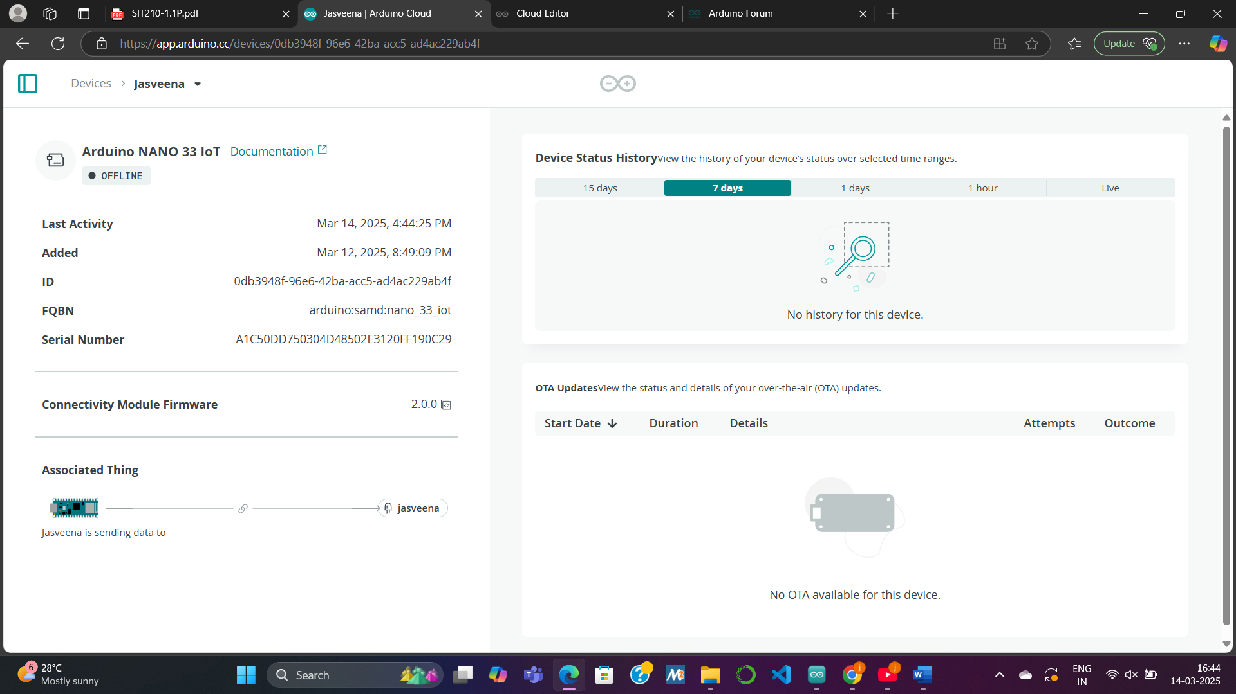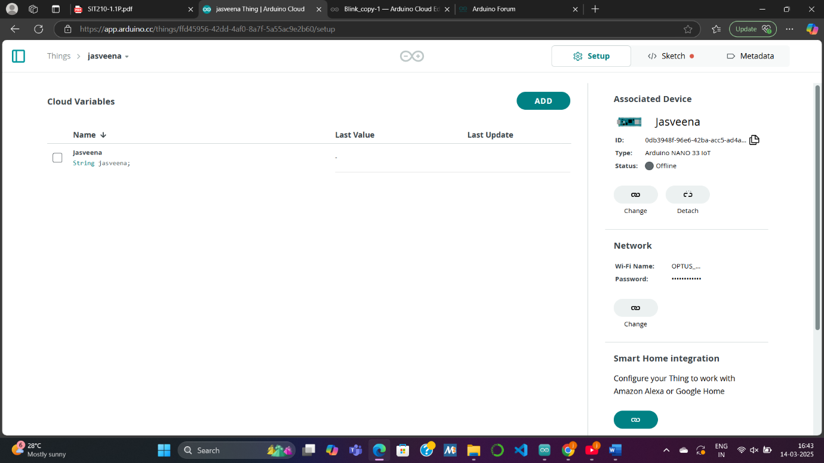

2.
Modular programming involves breaking down a program into smaller, independent functions, each responsible for a specific task. This approach makes the code easier to read , maintain and efficient . For the Blink LED program, modular programming can be applied in several ways to enhance usability.
First, input handling can be separated into a getUserInput() function, which reads user input from the Serial Monitor. This makes it easier to manage and modify input collection logic.
Next, a Morse code conversion function, getMorseCode(), translates each character to Morse code. This function can be reused throughout the program and makes the code easier to extend with additional characters if needed.
The blinking functionality can be modularized into a blinkMorseCode() function. This function will handle the LED blinking according to the Morse code for each character, improving readability and simplifying any future changes to the blinking pattern.
A display function like displayMessage() can handle all outputs to the Serial Monitor, centralizing how information is shown to the user and making it easier to update messages in the future.
Finally, the program flow is managed by a processUserInput() function, which organizes reading input, converting it to Morse code, blinking, and prompting the user again.
With modular programming, the program becomes easier to debug, extend, and maintain, as each function focuses on a specific task. It also makes the code more readable and reusable for future projects.

3. link to the repository on github :
https://github.com/jasveena15/task-1.1-blink-name.git

4. youtube video link :
https://youtube.com/shorts/NoaQ_4d5jKI?feature=share

